**Tutorial**

The tutorial contains two distinct parts: an “onboard” part that deals with non-combat procedures and a “on world” part, that introduces combat.

**In part** 1: Introduces the player to the main game mechanics on the ship using the mysterious AI.

* **Room 1**:
  + You are shown to be put together by a massive machine before getting up and walking out of it and revealing to be in a small room with a singular door
  + The overheard AI tells him that there are items in the room in which explains his purpose. He must collect them and then open the door. (*The door won’t open if the player doesn’t complete the two objectives things.)*
  + After that, the player must complete two things:
    - There will be a book item on a table on the right side of the door. This allows the player to figure out that there will be book items and teaches them to pick it up. This book has his mission parameters and activates the Hud.
    - There are also two weapons on another longer table to the left side of the door. This allows the player to pick up both weapons for the first time and learn how to equip them. They can shoot them and when they pick up the weapons, there will be a text popup that tells the shoot controls. If they empty the clip, the reload mechanic will pop up.
  + Lastly is a door which can only be opened if the two objectives are completed. Once those are completed, the door with have a pop up when approached, telling the player the control to open it.
* **Main Hub Room**:

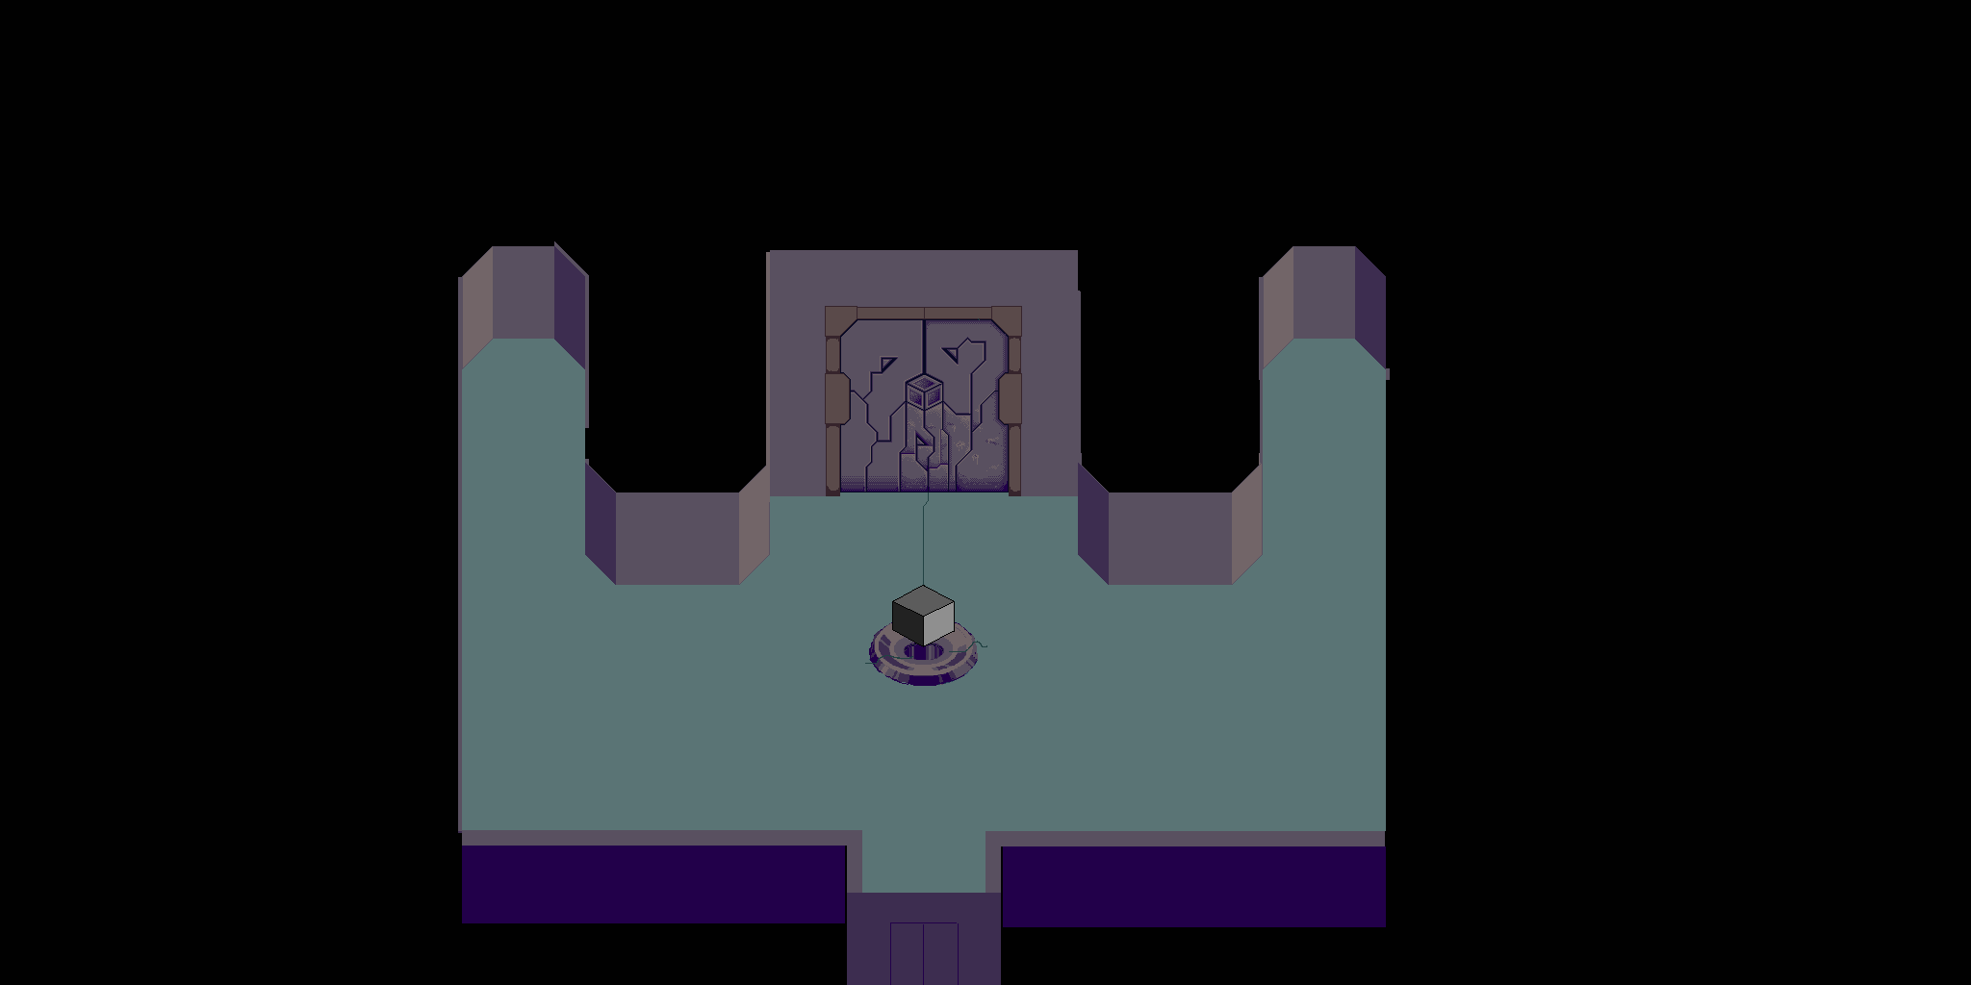



* In this main room, which is the main hub room for the rest of the game, you’ll find the pedestal for the cube pieces(C), the end game boss door(B), the respawn chamber(D) and the ground world teleporter(A).
* The player cannot teleport to the world until they have looked at each of the other three items.
* Once they have talked to them, the world teleporter will light up and the player can move to the second part of the dungeon, pressing the control to use the teleporter.

**In part 2**: Introduces the player to the combat system. This includes:

* How to attack
* Health and shields
* Enemies

The Dungeon has an empty "Start" room that served as a moment and an intro to the dungeon. It also allows for the player to fool around with their gear and prepare before starting the dungeon.

When you enter the first room in the Dungeon, there will be one enemy that can shoot at you. You must kill it at this point.

* Teaches combat with guns only, no shield. Also will show the reloading mechanic.
  + This first enemy will be a special one, very strong bullets and extremely accurate. To make sure the player gets hit. Cannot kill the player. Leaves them at one health.

Once the enemy is killed, the door will open and the player can proceed to the next room.

* Teaches the room clearing mechanic

The next room will have a new weapon and two health packs. The player must pick up all items to proceed.

* Teaches the weapon switching mechanic along with the health packs.

Once both those are picked up, the player can proceed to the next room. This is the last tutorial room and has a shield in it.

* Once the player picks it up and tests it, they can proceed into the first room of the dungeon.

***Why is this interesting?***

It’s transitioning between environments and its quick. It doesn’t bog down the player immediately with an insane amount of instructions but rather just teaches them as the player is presented with them. That’s why the combat isn’t taught until after the player has reached the dungeon. They don’t need combat in the ship, so why teach it there.